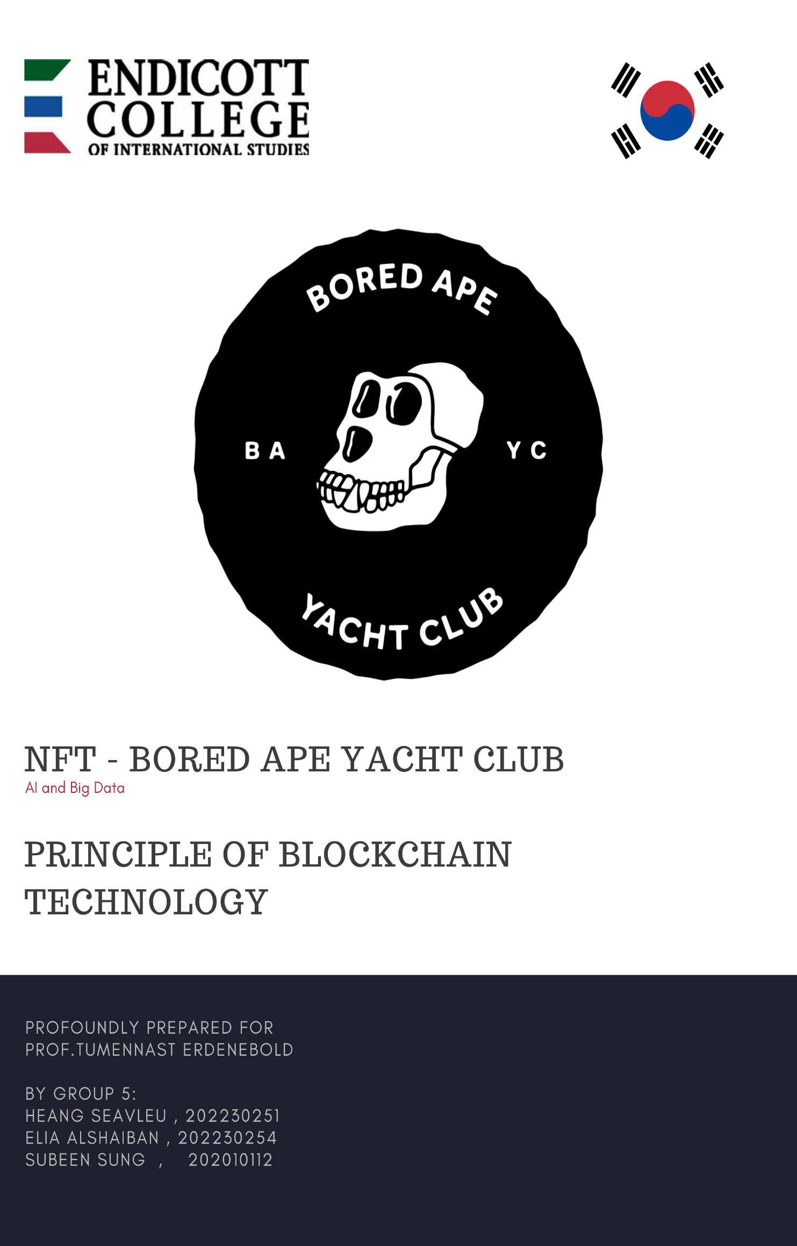

Contents

1. What is NFT? - 1 -

2. What is Bored Ape Yacht Club? - 1 -

3. Team - 1 -

4. Timeline - 2 -

4.1. When - 2 -

4.2. Where - 2 -

5. Technology - 3 -

6. Pros and Cons - 3 -

7. Tokenomics - 3 -

7.1. Token Supplies (Smart Contract) - 3 -

7.2. Supply and Demand mechanism - 3 -

7.3. Roadmap - 5 -

8. The 6 Metrics Method - 6 -

**Total volume trade** - 6 -

**Floor price** - 6 -

**Rarity** - 6 -

**Number of unique holders** - 7 -

**Market Cap** - 7 -

9. Conclusion - 8 -

References: - 9 -

# 

# What is NFT?

It is a non-fungible token, and it is a blockchain-based digital asset known as NFT or non-fungible token. Anything can turn become an NFT, including works of art, sports collectibles, and even tweets. You can buy NFT on Opensea or LookRare with Ethereum coins.

# What is Bored Ape Yacht Club?

According to the Bored Ape Yacht Club it indicated that "BAYC is a collection of 10,000 Bored Ape NFTs—unique digital collectibles living on the Ethereum blockchain. Your Bored Ape doubles as your Yacht Club membership card, and grants access to members-only benefits, the first of which is access to THE BATHROOM, a collaborative graffiti board. Future areas and perks can be unlocked by the community through roadmap activation." So, implying that It isa collection of 10,000 bored ape NFTs which sell on the Ethereum blockchain. And This NFT collection can ever generate on the circulation market for only 10,000. It can never go beyond that according to what the smart contract mentioned.

# Team

The founder of BAYC is ‘Gargamel’ (Greg Solano, Writer and Editor) & ‘Gordon Goner’ (Wylie Aronow, the son of board tycoon) whom describe themselves as ‘literaty bros’

- He grew up together in Miami

- Initially bonded by arguing about the work of David Foster Wallace.

- In an Interview, "they evoked Austrian-British philosopher Ludwig Wittgenstein's idea of the unutterable to describe ‘Bored Apes’. "

- They identities were revealed, respectively, by BuzzFeed News in February 2022.

- In February 2021, they were not crypto savvy, having both written their first lies of Solidity. So, they brought two friends Solano and Aronow came up with the concept of "a shared digital canvas: anyone who bought in could draw on it." They likened this canvas as being used like a bathroom at a dive bar; this idea stuck with the two, and they created a science-fiction storyline centered around on it. In an interview with The New Yorker, Aronow elaborated on the concept, which centered on early cryptocurrency investors all becoming billionaires: Mascote Apes ‘No Sass’ & ‘Emperor Tomato Ketchup’ Designer: All Seeing Seneca, an Asian American artist Lead Artist of the original collection

**Glossary:**

<- cryptocurrency phrase ‘**aping in’**, meaning to buy into a new currency or NFT with abandon, risking a significant amount of money

<- unknown, programmer code, a language used for smart contracts

# Timeline

## When

This project start when 4 American friends gathered and said, 'What do users do in the Crypto market and have fun?’ In response to this question, they created the Bored Ape Yacht Club project. So, On April 23, 2021, BAYC was first minted by Yuga labs, the company they founded together.

- Later in April 30, 2021, all 10,000 were sold out in 12 hours after the issue began at about $220 (0.08 ETH).

- And they hit an all-time high. And on March 11, 2022, it was announced that Yuga Labs acquired all of the CryptoPunks and Meebits intellectual property for an undisclosed sum. Yuga Labs stated they were granting complete commercial rights to CryptoPunks owners.

- On March 16, 2022, ApeCoin DAO, a decentralized autonomous organization launched its own token separate from Yuga Labs known as "ApeCoin (APE)"

- On April 30, 2022, Yuga Labs launched its metaverse Otherside, as a collaboration with Animoca Brands. Bored Ape NFTs feature in the music video for Eminem and Snoop Dogg's song "From the D 2 the LBC".

## Where

BAYC was made in the United States. They have another unique characteristic. BAYC had a world view of their own hideout created by monkeys who became very rich and bored with everything in the world due to soaring prices of virtual assets and cryptocurrency. And in line with the word "club" in the name of the project, he socializes with people in the virtual world through his own monkey, often holding meetings in the real world. This can be said to be their special and advantage.

# Technology

**What makes it valuable?**

Reasons of what made it valuable is based on four things. The community made it valuable, for having only 10k bored Apes, this made the members showcasing their NFT’s as profile pictures on social media, and with celebrities influence like Justin Bieber or even co-creations and commercials like adidas, they bought a Bored Ape and made it their profile picture on social media.

Another reason is it gives benefits to it user for playing games, like the mutant arcade.

And another reason of its high value is how it made sure to stay interesting, even after all the 10k bored apes are sold, it did other things, like the kennel club, where you adopt a dog for your ape, and the mutants and serums, where you make more versions of your ape.

**What made it grow rapidly?**

Some reasons that made it grow fast is giving people the freedom of creativity, and constant content drops which makes people want more and hold onto their apes. Another reason is the transparent communication and co-creation with the community members.

**Provenance**:

In the provenance there is a record of every Bored Ape that ever existed. It is firstly hashed using the SHA-256 algorithm. The final provenance record is stored on the smart contract. To get that final proof we use the SHA-256 algorithm on the combined string, and to get the combined string  we combine the SHA-256 of each Bored Ape image in a specific order and make a long list.

Each Bored Ape token ID has a initial sequence and to get that we do this formula:

(TokenID + startingIndex)%10000->Initial Sequence Index

Here you can see the starting index, the contract address, the final proof hash, and the arweave URI.

The next picture is the concatenated hash string.

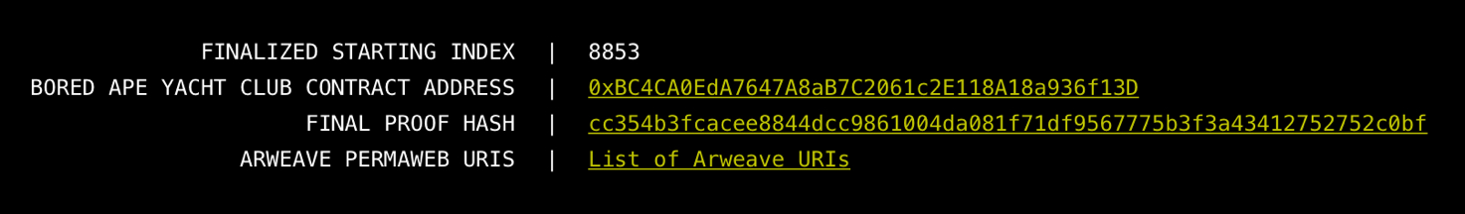

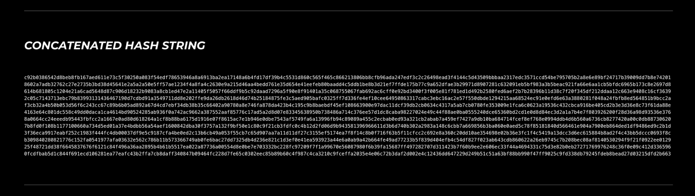

Here is the long list where there is the initial sequence index, the token ID, the SHA-256 hash and the IPFS hash. (Interplanetary file system)

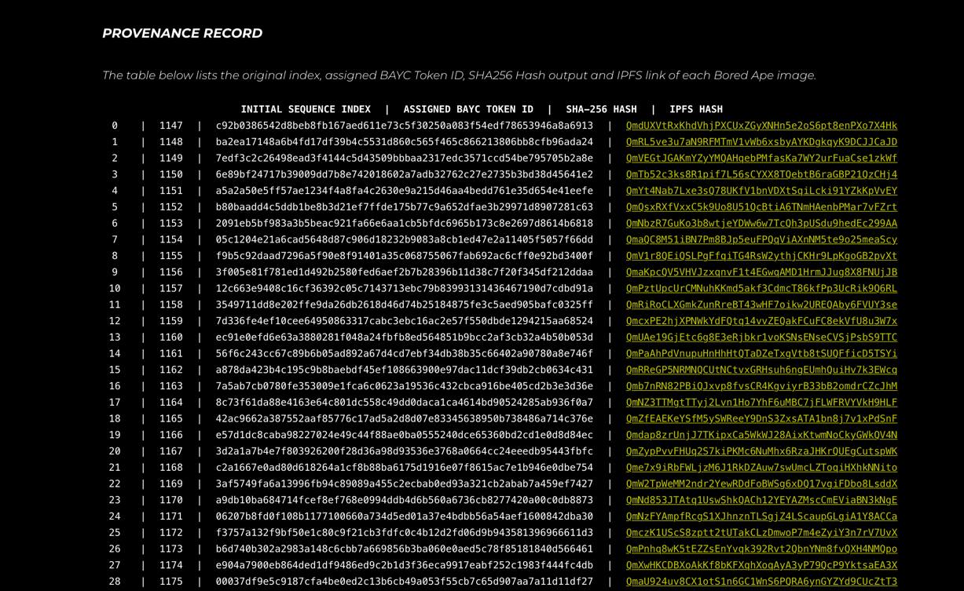

**MAYC:**

It’s a collection of 20 thousand mutant that can be created by owning an existing Bored Ape.

It was made for the original holders as a reward.

It is made in the vial of Mutant serum or by minting a Mutant Ape in the public sale.

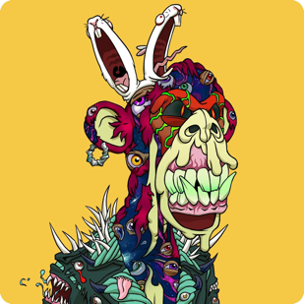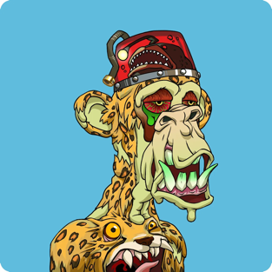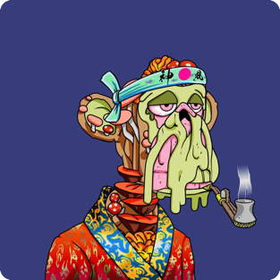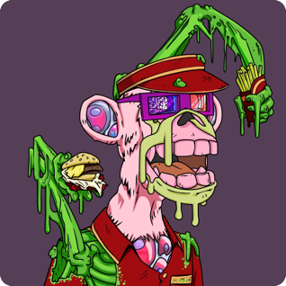

**Serums**:

Mutants are created with serums that has 3 tiers: m1, m2, m3 (Mega Mutant)

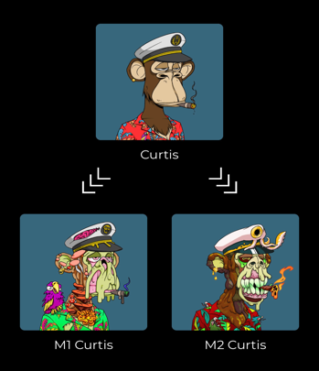

**The process:**

**Distribution and the pricing:**

10k mutant apes would be available to mint in a public auction, the price to mint a mutant will start at 3 ETH. The price would reduce to 0.1 ETH over the course of 9 hours. This is to allow the community to set a fair starting fair price and to avoid any gas war.

During minting, the mutant apes will be hidden/unrevealed, when the public sale is completed, a randomized starting index will be minted during the sale. After the starting index is set, the members can mutate their apes with serums.

**Mutation**

Mutation is only available for the BAYC members, the BAYC token holders can apply the serums to their bored apes, applying the serum to a Bored Ape will burn that serum, then creates the mutant NFT, which can retain aspects of the original Bored Ape. The bored ape NFT won’t be harmed.

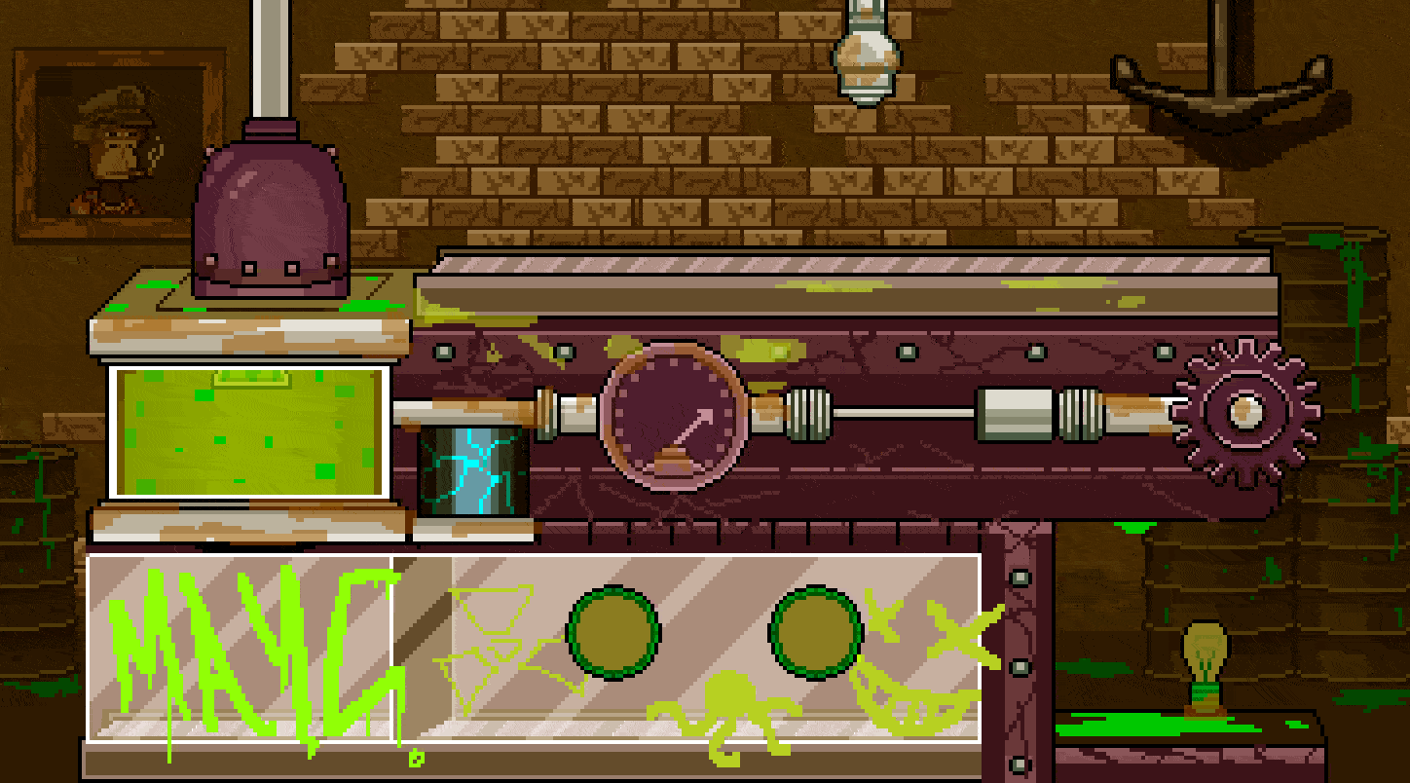

**The mutant arcade**

in the arcade you fight the mutant ape and try to reach for the surface. After beating it, some eth will be added to your wallet address

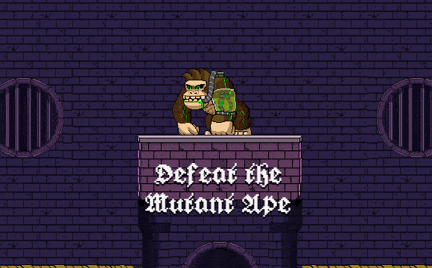

**Kennel Club Adoption**

The Bored Ape Kennel Club was made for one week, it’s limited for only the members of the BAYC. If you have a bored ape in your wallet, you can adopt a Club Dog NFT for free, you only have to pay for the gas. You claim a random dog, once it’s claimed, you can’t change it. When the week ends, the dogs are revealed, and for the unclaimed dogs, they are released in the swamp, never seen again.

# Pros and Cons

Pros:

* 10,000 BAYC NFTs, which makes it unique
* membership: free nfts from mayc and kennel club
* Access to limited edition merch and exclusive member-only areas

Cons:

* Very pricey
* Very difficult to buy, and only uses ETH cryptocurrency using meta mask

# Tokenomics

The term of Tokenomic is a combination of Token and Economic. Tokenomic is a digital unit of a cryptocurrency that is either used as a specific asset or represent a particular use on blockchain. A project’s coin/token with organized and solid tokenomic held high potential of sustainability and longevity.

To make the right decision whether to invest in a project or not you should consider analysis these two-prime factors of the token or coin: Token supplies (smart contract), and Supply-Demand mechanism.

## Token Supplies (Smart Contract)

Legitimately every single token must have a token supply which often shown in the project smart contract. The most essential metric relevant for supply is the maximum token supply – also known as hard cap. To investigating into the future of what a holder could have with the project you must study these three main components of the ‘Token Supply’. This included max supply, circulating supply or Total supply.

A maximum apes supply is exactly how it sounds, it indicates the maximum amount of the ape token that can ever be generated. For bored ape yacht collection it could ever generate for maximum 10,000 tokens on the circulation only, referring that it will never exceed that number no matter under which circumstances.

The next metric is the Circulating supply or Total supply. Simply, circulating supply demonstrate the amount of NFT is being traded in the current market or in another definition is the number of publicly issued token in circulation or locked somehow. So, the more the circulation supply increase nearer to the max supply it dictates the amount that has been left to be mined and it also indicated that the project is actively mined by miners which is a great sign for investing in a project.

## Supply and Demand mechanism

Economic is always up and down and investors invest in the future. An investment can be made with the intention of gaining an appreciation for the acquired asset. The gains from an investment can come in two ways: one is by way of reselling the asset when its value has increased over time, and the other is by way of an income-generating plan, that promises a stream of income after investing a certain amount in it. So, to ensure you to know if the project has future or not you should consider study about the supply and demand mechanism of the project.

By compare the supply and demand mechanism of BAYC to Cryptokitty you could know how to analyze the project.

Figure 1Group 5

What we want to do in here is first to check if the project has the max supply. When supply is low demand will push the price up, we have less worry about the inflationary of the project of being dumped by all the apes in the market at once. As for BAYC it has fixed supply of 10,000 meaning it can’t not go over it, so simply scarcity made the project valuable.

While Cryptokitty it is a new breeding technology that allow token owner to breed new kitty by combining two kitties together hoping to get new unique token which could has higher value. This could potentially increase the supply where the demand can not caught up with it will drastically decrease the value of the token. The reason is that investors and people value things, objects, or tokens that is rare, rareness equal high value, so if anyone could breed new Kitty meaning that as it continuously grow more and more the token will likely decrease the scarcity. Which in turn, supply goes up forever, demand go down.

So, to maintain the supply and demand mechanism. The community can burn their collection. This underlying tactic is used to manipulate the market price of a token. When you burn a bored ape yacht token, it means you are withdrawing your token from circulation indefinitely. Once you permanently remove your NFTs from circulation, you reduce the total supply. This will in turn increase the scarcity of your existing tokens if thoughtfully executed.

## Roadmap

The next crucial element is the roadmap. You may determine the future of the project of when and where to buy and sell your token while keep yourself up to date with the new thing has been distributed in the ape community. Investors using this metric to analyze the different Hype cycle of the BAYC.

Figure 2Group 5

You can observe the Time-Window in which excitement can fade. So, what the company can do is add a new quality to the project. Because investors want to invest in things that have value in return so if the project doesn't have a future why would they want to stay?

Obviously, what could happen is they will dump the token. which can drastically affect the inflationary of the market cap. So, to keep up with the Yuga company provide their community with this vision of their project future.

# The 6 Metrics Method

Another strategy we could apply for the project analyze is the 6 metrics method. This method involves studying about the Total Volume Traded, Floor Price, Rarity, Number of unique holders, Market Cap, and Diamond Hand Balance.

**Total volume trade** shows the overall demand for project. It shows how popular an NFT project is, if it reaches a higher volume, it indicates people's willingness to buy and sell. The Total volume trade of BAYC is 679,688ETH = $853545393.52

**Floor price** is the lowest price in the project collection. The floor price of BAYC is 691,369ETH = $868214276.51. To avoid falling into floor prices potentially manipulated by a sweep, you should review the transaction history of the ape you plan to buy. The more the token has been sold and bought the chance of selling it at a hot price is high.

**Rarity** is the traits and characteristics determine the rarity of an NFT, referring to the difficulty of obtaining it, hard to obtain = high value. Rare BAYC attracts more buyers and sells at a higher price. BAYC is a collection of 10,000 bored ape NFTs. It has over 170 unique traits include expression, headwear, clothing, eyes, mouth, Hat, etc.

**But why need a piece of art with just some rarity?**

* NFTs with a higher rarity rank might often come with additional exclusive NFT utilities such as metaverse tickets, concert tokens, etc. [Graphical user interface, application

  Description automatically generated](https://rarity.tools/boredapeyachtclub)

## **Number of unique holders**

According to Opensea there is 64% of unique holders.

## **Market Cap**

So, another fundamental analysis you ought to learn is the market capitalization or market cap. With market cap you could actually analysis how much money is invested into the project, and this also show you how potential the coin held as well. Normally, to calculate the market cap you just need to perform a basic formula of multiplication.

**Market Cap = Price * Circulating Supply**

](https://www.coingecko.com/en/nft/bored-ape-yacht-club)As of 2022 Nov 12 the Market Cap shown as below image.

**Diamond Hand Balance** 'Diamond Hands' refers to someone who has a high-risk tolerance for high-volatility stocks or assets that they own that is the definition on what MyWallst website claimed.

# Conclusion

BAYC is risky project, for having its prices rising so fast in the recent months, where it might fall in the future. Put for its popularity, investing can be smart if you are willing to take a risk, for you can later make a big win, and it’s assured that BAYC is not disappearing anytime soon and has a long successful journey.

# **References:**

1. Diamond hand: https://mywallst.com/blog/what-does-the-term-diamond-hands-mean
2. Official site: https://boredapeyachtclub.com/#/
3. Opensea: https://opensea.io/collection/boredapeyachtclub/analytics
4. Bored ape yacth youtube: https://www.youtube.com/channel/UCB6R9NAjkgxQi_QEkc4O25Q
5. Coingecko: https://www.coingecko.com/en/nft/bored-ape-yacht-club
6. NFT Tokenomic: https://www.youtube.com/watch?v=tD6Tpk7hGWI
7. CryptoKitties Official Web: https://www.cryptokitties.co/catalogue/cattribute/fox
8. <https://en.wikipedia.org/wiki/Bored_Ape#Founders>
9. <http://wiki.hash.kr/index.php/BAYC>
10. <https://www.marieclairekorea.com/culture/2022/10/bay-c-is-coming/>
11. <https://www.bao-bab.co.kr/column_board/152736>
12. What is diamond hand: <https://mywallst.com/blog/what-does-the-term-diamond-hands-mean>
13. Etherscan:https://etherscan.io/address/0xbc4ca0eda7647a8ab7c2061c2e118a18a936f13d#tokentxnsErc721